
STUDENT NAME:B.Anjali
REGISTER NUMBER:192371062
COURSE CODE:CSA0903
COURSE NAME: Programming in java
GUIDED BY: Magesh kumar
DATE:22-07-2026

Pattern Program 1: Right-Angled Triangle of Stars
- Problem Statement:
Write a C program to print a right-angled triangle of * stars for a given number of rows.
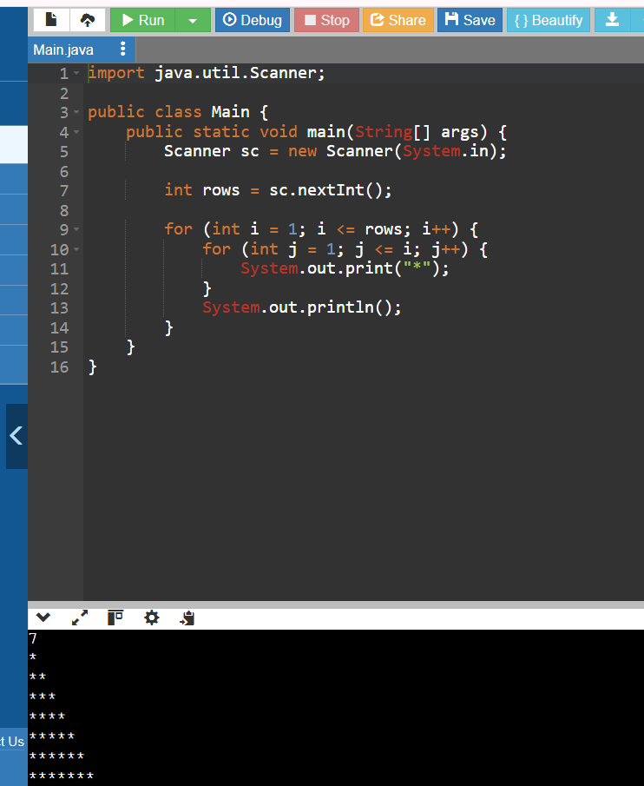

Pattern Program 2: Number Pyramid
- Problem Statement:
Write a C program to print a number pyramid pattern based on the number of rows.

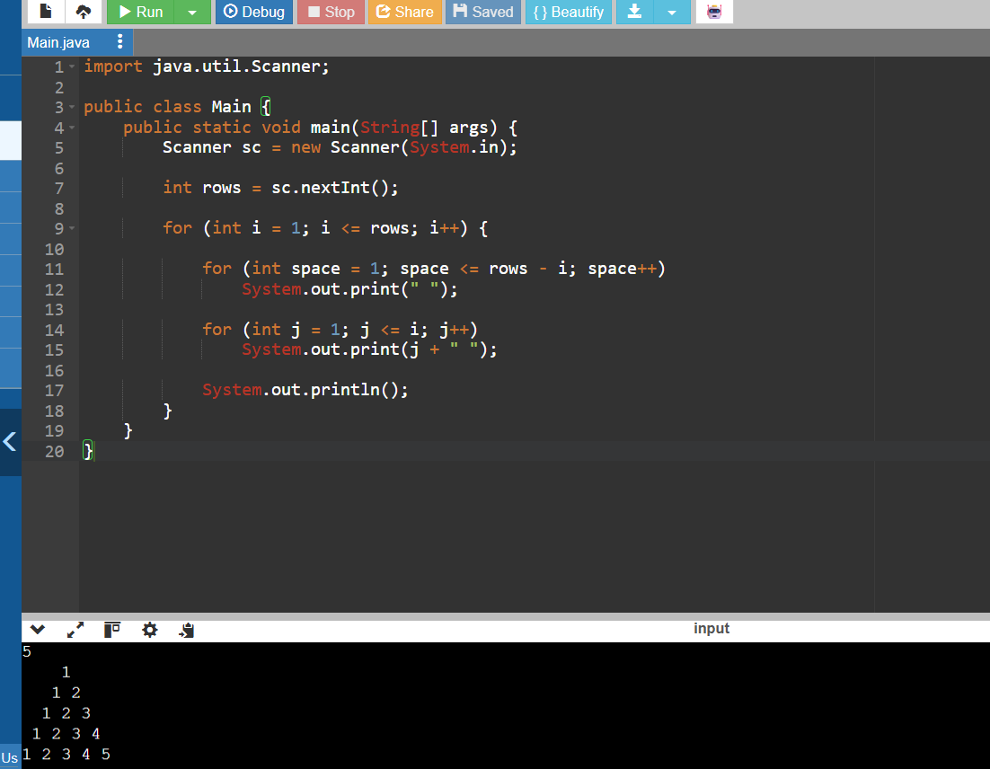
- Hollow Square Pattern
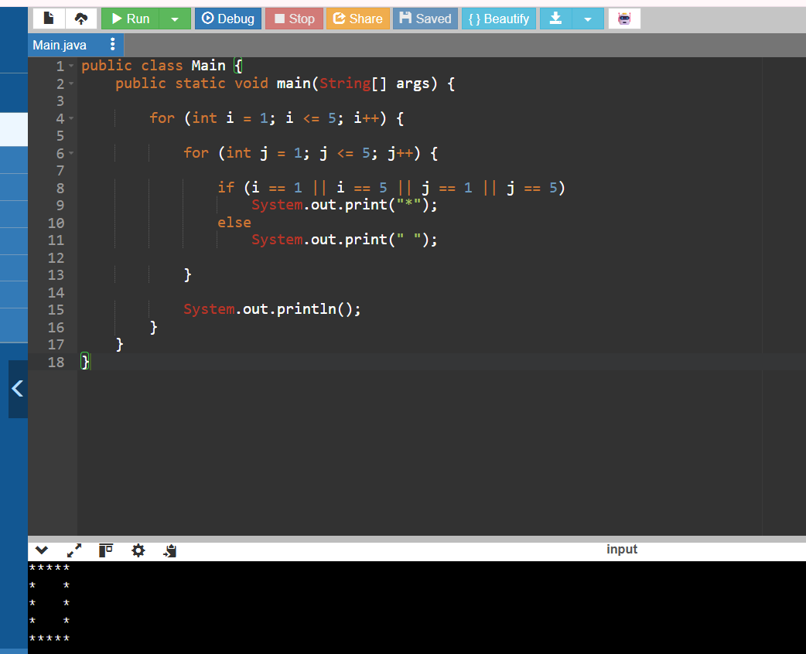
Number Right-Angled Triangle
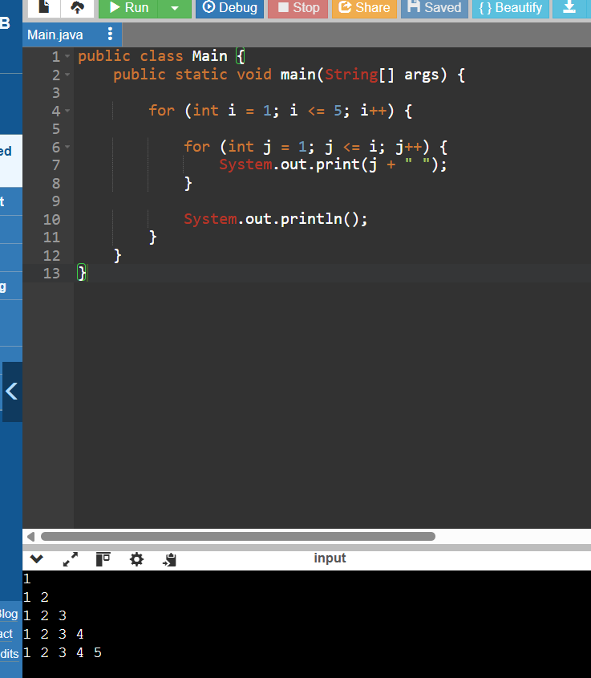
Alphabet Triangle Pattern
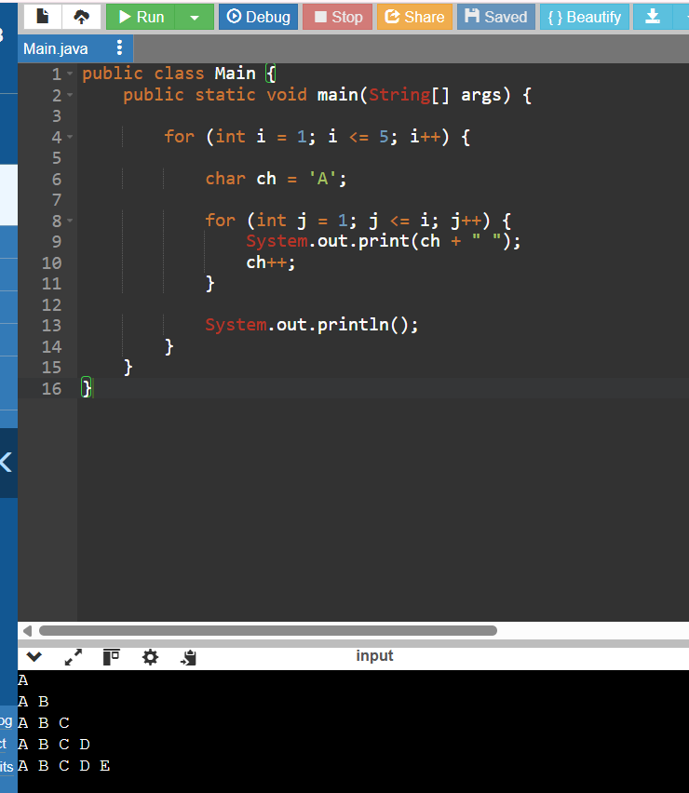
Diamond Star Pattern
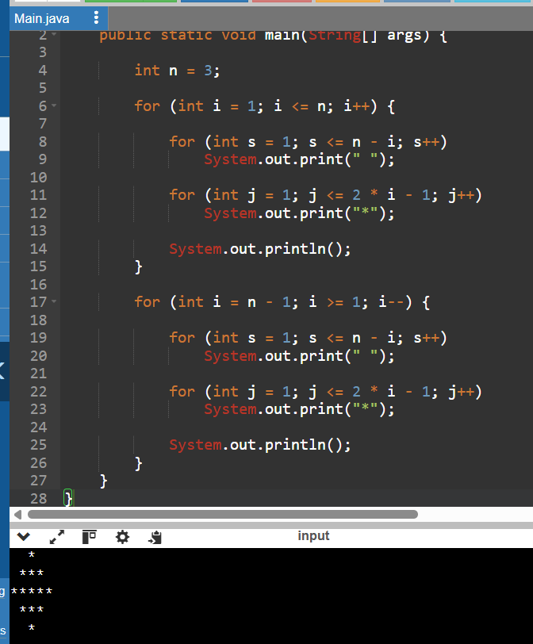
Floyd's Triangle
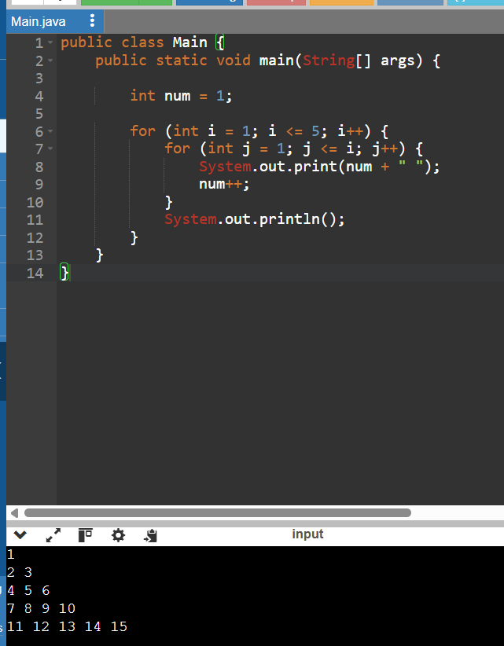
Right-Aligned Star Triangle
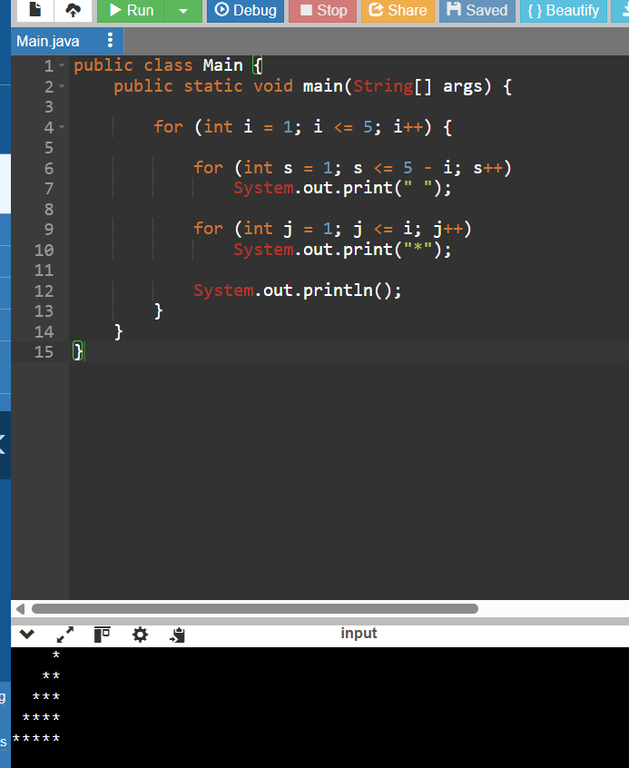
Inverted number triangle
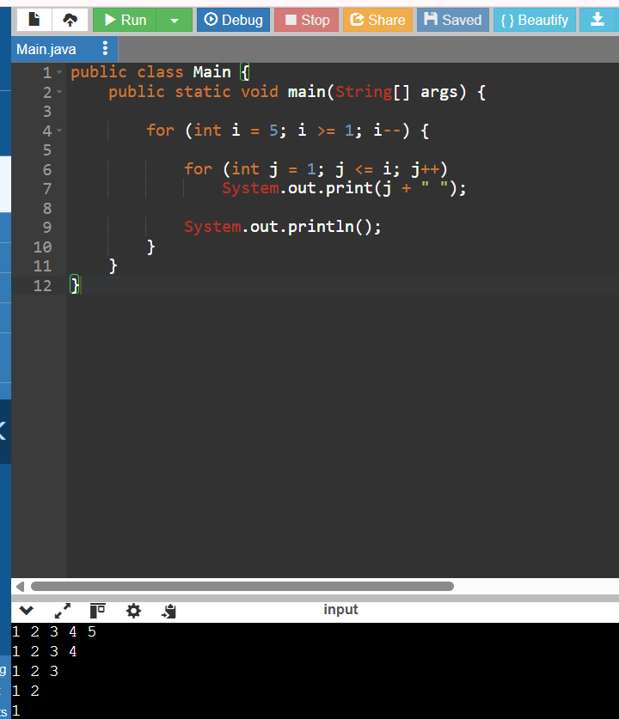

Binary number triangle
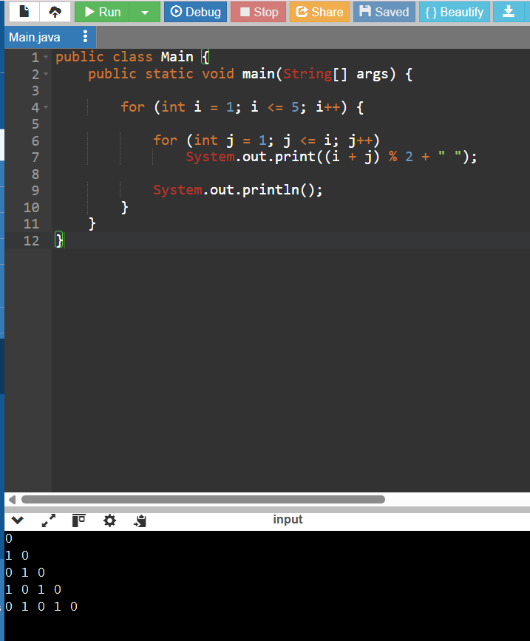
Half diamond star pattern
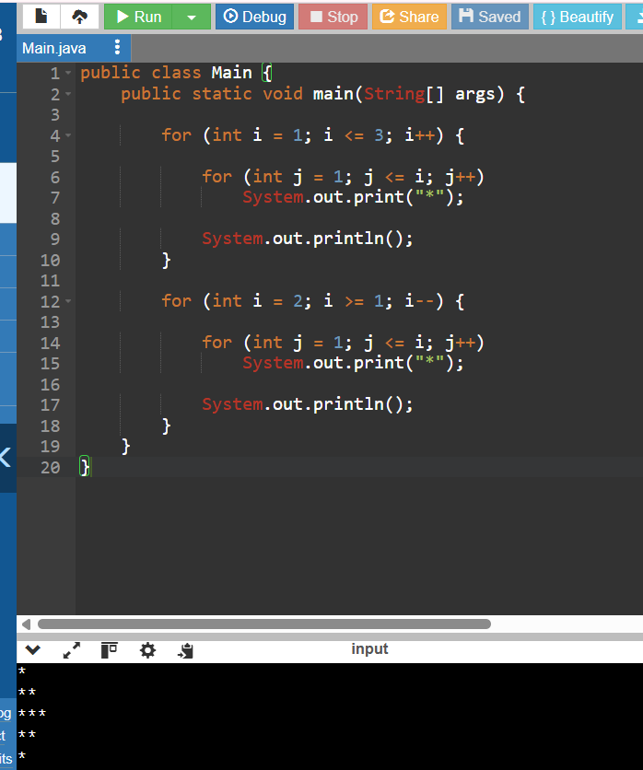

Hallow right angled triangle
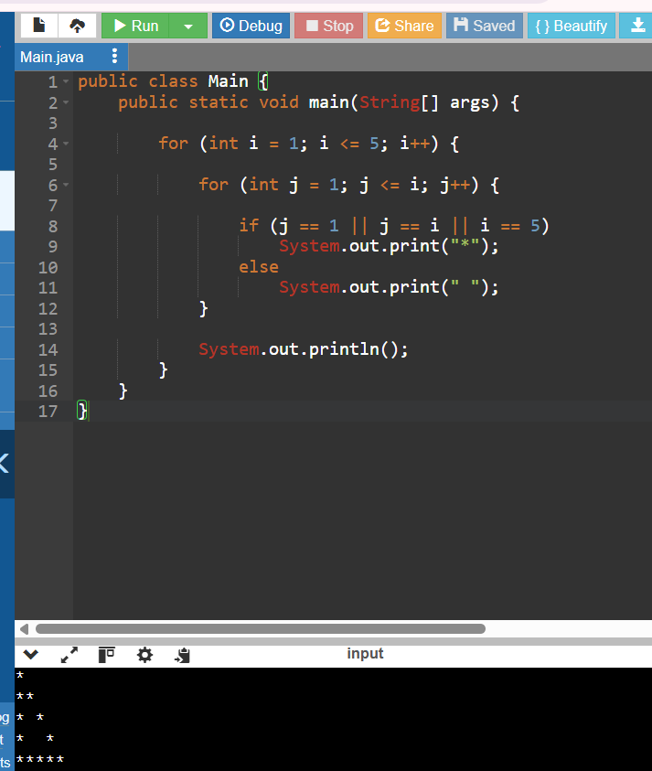
Reverse pyramid of stars
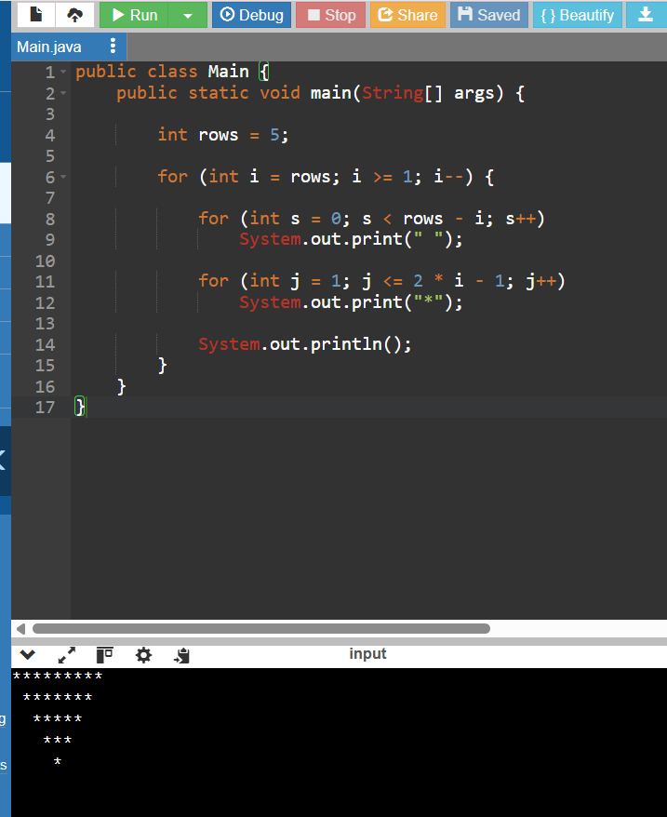

Continuous characters triangle

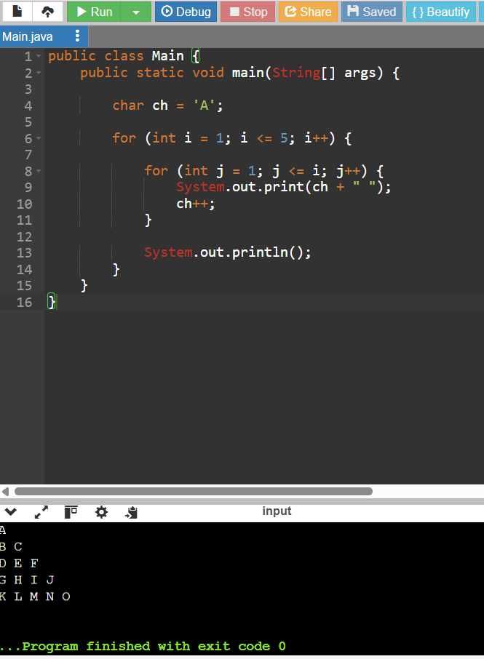
Right angled-triangle with even numbers
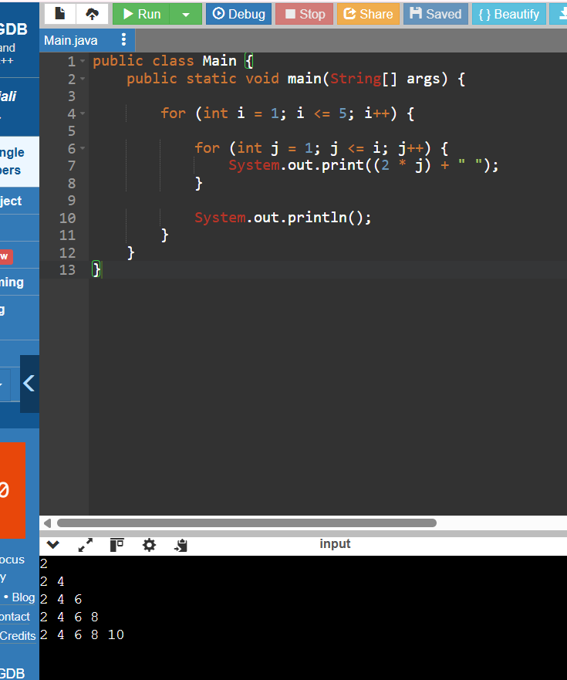
Triangle of odd numbers
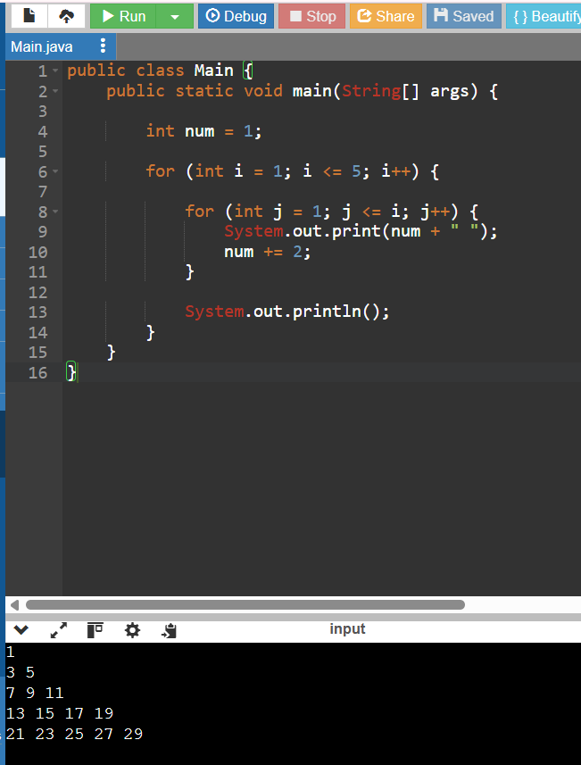
Hallow pyramid pattern
